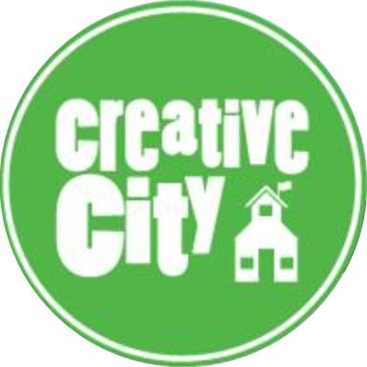

POSITION: Part-time Special Education Teacher
Reports to: Principal
Start Date: August, 2017
Posted: February, 2017

About Us
Creative City Public Charter School (CCPCS) is a progressive charter elementary school located in the Park Heights community of Baltimore City that offers a place-based (project-based) and art-integrated instructional program for grades K through 5th. Our school, founded by a group of parents, opened in the fall of 2013.

Teaching From Our Core Values:

We are a Community
Our school community operates as a family. Our supportive environment allows safe space for teachers to take risks in their practice and grow professionally.

We Connect with Each Other, Our Environment, Our Neighborhood, & Our World
Connection with students is critical. One-on-one relationships with students will break down barriers and open doors for deep learning. Our place-based approach uses the built and natural environments around us as a foundation for learning, bringing authenticity and personal connections for students.

We Care
Care for one another (among students, families, staff, and school-wide) is at the core of our thinking. As a Community School we are a resource hub for students, families, and our surrounding community that can be responsive to unique needs. We care deeply about equity for all students across racial, socio-economic, and other boundaries.

We Question
We build on the inquisitive nature of children to drive our project-based, arts-integrated curriculum, with the goal of fostering self-directed critical thinkers. We also constantly reflect on and adjust our own practice as a school.

We Collaborate
Our shared governance structure enables all stakeholders to participate in critical decision-making for our school. Collaboration and peer-to-peer learning is key, and fostered through a schedule that prioritizes common planning time for teams and ongoing professional development. These are also values we instill in our students through ongoing practice in collaborative classroom work.

We Create
What one child easily learns from reading a text, another might need to experience differently to fully process. We prioritize art class and music class, as well as arts-integrated study in the general classroom to appeal to all learning styles. Teachers are not required to practice their own art form, but unique creative expression among teaching staff is welcomed and encouraged.

General Job Description:
At Creative City, the special education teacher’s role is to develop and implement effective instructional practices based on the needs identified in students’ Individualized Education Programs (IEPs). The teacher will develop, implement, and monitor students’ IEPs in collaboration with general educators, related service providers, parents, and other IEP Team members. The teacher will promote a collaborative relationship with school staff and parents that will foster inclusive education practices to the greatest degree possible.
Bachelor’s degree required. Master’s degree preferred. The successful candidate will hold a Maryland teaching certificate with endorsements in the area of elementary special education or special education K-12.

Qualifications
Teachers should:
- Be passionate about progressive education, collaborative governance, improving urban education and using community partnerships to propel the mission of the school
- Believe in the potential, curiosity, and creativity of all children
- Provide unbiased and culturally responsive instruction that reflects the multiple perspectives of students and our school community
- Embrace a culture of data-driven decision making and the implementation of evidence-based approaches to instruction
- Engage in regular self-reflection on practice
- Be committed to an equitable, holistic, rigorous, and engaged experience for each student
- Respect students, fellow teachers, parents, and community members as active participants in learning and school culture
- Be devoted to the relentless pursuit of excellence in education within the CCPCS model
Minimum Qualifications
- Maryland Standard Professional Teaching Certificate for appropriate level grades and content areas
- Experience working with elementary students
- Bachelor’s Degree from an accredited institution
- Excellent oral, written, and interpersonal skills
- Previous experience within Baltimore City Public Schools is a plus
Strongly Preferred
Experience with any of the following:
- Place-based education
- Arts Integration
- Project-based learning
- Culturally Responsive Teaching
- Balanced Literacy programs such as Fountas and Pinnell, Lucy Calkins Units of Study, Words Their Way, etc.
- The Singapore Math approach to teaching mathematics
- Responsive Classroom
- Working within a shared governance model
- Service Learning/Community Involvement
- Urban education/Baltimore City Public Schools
For a more information about CCPCS, visit http://www.creativecityschool.org.
To apply: Please email resume & cover letter to Hiring@CreativeCitySchool.org. Please make sure that your resume and cover letter reflect any experience with the qualifications listed in the job description, especially strongly preferred areas. Also include a list of 3-5 references (2 of which MUST include a current or previous supervisor) and a Philosophy of Education (1-pager describing your philosophy of education and how that philosophy makes you a good match to Creative City’s mission).

